In [software testing](https://www.javatpoint.com/software-testing-tutorial), we have four different levels of testing, which are as discussed below:

1. **Unit Testing**
2. **Integration Testing**
3. **System Testing**
4. **Acceptance Testing**

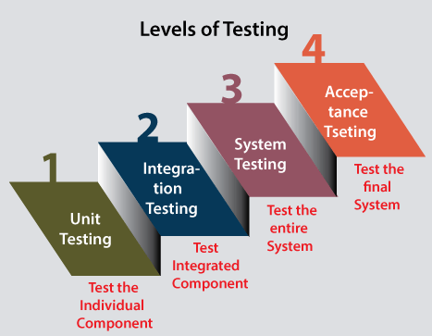

Level1: Unit Testing

* which is used to test if software modules are satisfying the given requirement or not.
* It involves **analyzing each unit or an individual component** of the software application.
* Unit testing is also the first level of [**functional testing**](https://www.javatpoint.com/functional-testing).
* it is the smallest testable part of the software. The reason of performing the unit testing is to test the correctness of inaccessible code.
* Unit testing will help the test engineer and developers in order to understand the base of code that makes them able to change defect causing code quickly. The developers implement the unit.
* Level2: Integration Testing
* It is mainly used to test the **data flow from one module or component to other modules.**
* In integration testing, the **test engineer** tests the units or separate components or modules of the software in a group.
* When each component or module works separately, we need to check the data flow between the dependent modules, and this process is known as **integration testing**.
* We only go for the integration testing when the functional testing has been completed successfully on each application module.
* In simple words, we can say that **integration testing** aims to evaluate the accuracy of communication among all the modules.

### Level3: System Testing

* which is used to test the software's functional and non-functional requirements.
* It is **end-to-end testing** where the testing environment is parallel to the production environment. In the third level of software testing, **we will test the application as a whole system.**
* To check the end-to-end flow of an application or the software as a user is known as **System testing**.
* In system testing, we will go through all the necessary modules of an application and test if the end features or the end business works fine, and test the product as a complete system.
* In simple words, we can say that System testing is a sequence of different types of tests to implement and examine the entire working of an integrated software computer system against requirements.

### Level4: Acceptance Testing

* which is used to evaluate whether a specification or the requirements are met as per its delivery.
* In simple words, we can say that Acceptance testing is the **squeezing of all the testing processes that are previously done.**
* The acceptance testing is also known as **User acceptance testing (UAT)** and is done by the customer before accepting the final product.
* Usually, UAT is done by the domain expert (customer) for their satisfaction and checks whether the application is working according to given business scenarios and real-time scenarios.